|  |
| --- |
| Circle Language Spec: Parameters |

## Miscellaneous Parameter Topics

The following articles will explain some miscellaneous parameter topics, that are not part of the main idea of parameters, but seem worth explaining anyway.

### Parameter Passing

*Object*, *class*, *value* and *execution* are called system aspects of a symbol. The basic ones are covered in the articles *System Objects*.

Other programming languages have *parameter passings*. In the new computer language parameter passing is established by access controlling the system aspects of a parameter.

It is basically about being able to separately access control every *system command*.

Just as an example of how access controlling system commands can be seen as parameter passing we consider the ByRef parameter passing of the programming language *Basic*. A ByRef parameter passing’s object target can be set from the outside, and the value of it can be read and written on the outside and on the inside. You make it point to something, and you read and write its value.

Basically the following system commands are accessible:

Object Set Public

Value Get Private

Value Set Private

For a ByRef parameter it is not usual, that you read out the object aspect: meaning you do not *point to* a ByRef parameter, you just *make it point at* something. So the Object Get (‘point at’) command is inaccessible. ByRef parameters are also not Object Set on the inside. So Object Set Private is also inaccessible. So Public does not means that you automatically have Private access as well.

Which system commands are practical to access control, in order to establish the idea of parameter passing, is not that important. The most important thing is, that if you have access control over system commands, you can establish any known parameter passing.

Parameter passing can also be called *parameter access control*.

Examples of practical parameter access control may be covered later.

### Joint Display of Access Connectors and Object Relations

When you see a parameter as a relation between a command and an object, it used to be a paradox, that the parameter can always point to an object on the outside, even though the parameter passing said, that you can only point *to* the parameter.

This problem was taken away by completely separating the object relations on one hand, and on the other hand access controlling the system aspects of the parameter. In a diagram you will also see those two things separately displayed.

The relational position of the object and the way you can access it are separately expressed in the diagram, and not by means of the same lines.

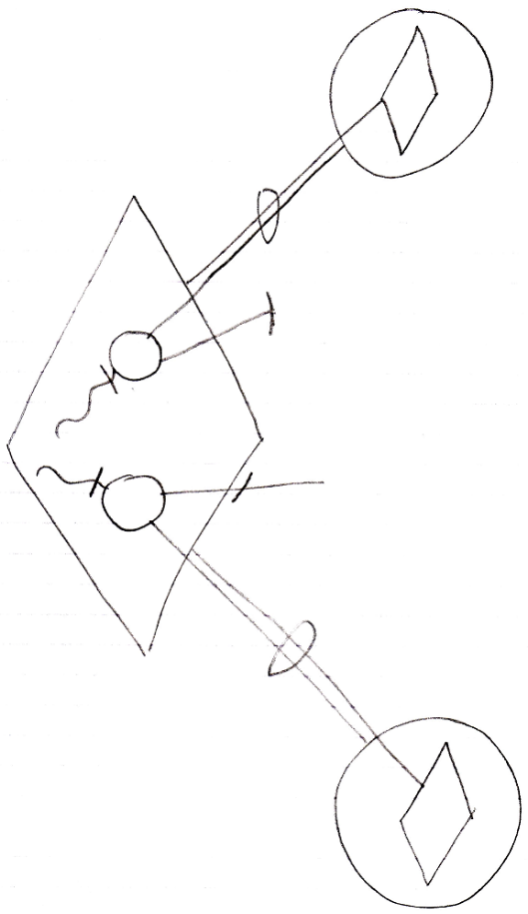

The open-ended lines of the circles inside the diamond are the parameters’ access connectors, that define how the parameter is or can be used. You can define a new relation to the command by tying an object to an access connector of a prameter. The access connector will not be taken *in use*, because after you’ve used it to define a relation to the command, the access connector is still there, open for usage.

### Parameters & Arguments

#### Concept

A command contains parameters. *Arguments* are what is filled in into the parameters. Basically arguments are the sources or targets of assignments, that have a parameter as a source or target. When the other side of the assignment, that is not the parameter, is outside the command, then that is the argument.

A parameter can be assigned a value. The source object of the value is then called the argument. Also, the value itself could be callled the argument, in contrast to the *source* of the value. A parameter can also be pointing to an external object. The object pointed to is the argument. Sometimes a parameter is not filled in at all, but is a created object by default anyway. In that case, the parameter is its own argument. When a parameter is pointed *at* from the outside, the pointer to the parameter is the argument. When a value assignment sources a parameter and yields over the value to another object, then the other object is the argument.

So an argument is what is filled in as the parameter, what is pointing to the parameter, or the object on an external end of an assignment, the other end of which is the parameter.

Since an argument can be a pointer to a parameter, and a parameter can be pointed to multiple times, a single parameter can have multiple arguments.

#### In a Diagram

The article *Parameters & Arguments* conceptually explained the usage of the term argument in relation to parameters. The current article gives examples of the diagrammatic expression of parameters and their arguments.

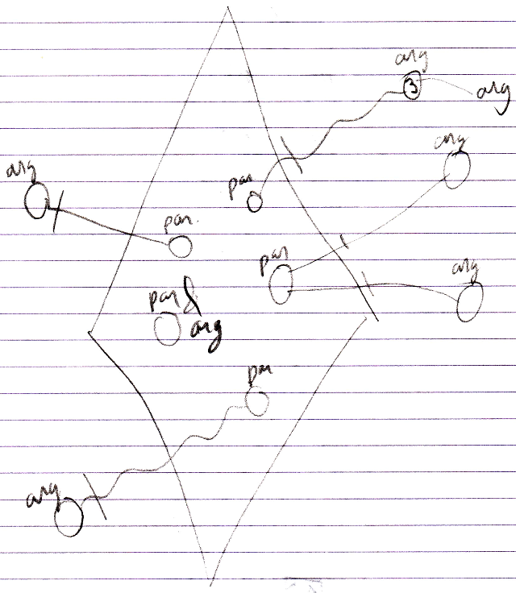

### Parameters For The Add Command

The Add command is a system command of a list. It can be called without any parameters. This will add a new item to the list.

But there are multiple ways to provide parameters to the Add command, that may come in handy.

These will simply produce different overloaded variations of the Add command.

First of all, the Add command could return the object, that was added, when the list automatically creates objects when adding a position to the list.

Secondly, when objects are not automatically created, then the *item position* in the list can be returned.

But those are just the basic Add overloads.

Some lists will automatically create an object when you call the Add command. But to occasionally prevent that, you can pass an existing object to the Add command, that will be put in the new position in the list. This will keep the list filled with created objects, without having unnecessary creation of new objects, that are immediately destroyed when replaced by an existing object.

Another application of parameters for the Add command, is providing *attribute values* as parameters in the call to the Add command. A standard Add command could be generated, that includes any attribute as an optional parameter. Then the caller of the Add command can choose which ones to fill in.

It is all up to the one that programs the behavior of the list.

Perhaps the designer of the list decides, it is required that you fill in attributes when adding an object to the list. He can then make those attribute values required parameters of the Add command, and make the other Add overloads inaccessible.

A set of default Add overloads could be generated as such by supporting the Add concept.

Perhaps object initialization on Add could be realized already by a neat, inline object initialization syntax in text code, and you would not need to make each attribute a parameter of the Add command. You would just need the Add overload, that takes a new object as a parameter, and use inline object initialization syntax.